实验1

R1

The device is running!

<Huawei>system-view

Enter system view, return user view with Ctrl+Z.

[Huawei]sysname R1-WW

[R1-WW]int g0/0/0

[R1-WW-GigabitEthernet0/0/0]ip address 12.1.1.1 30

[R1-WW-GigabitEthernet0/0/0]quit

[R1-WW]telnet server enable

Info: The Telnet server has been enabled.

[R1-WW] user-interface vty 0 4

[R1-WW-ui-vty0-4] set authentication password cipher 123

[R1-WW-ui-vty0-4] authentication-mode password

[R1-WW-ui-vty0-4] quit

Sep 18 2019 10:43:03-08:00 R1-WW %%01IFNET/4/LINK_STATE(l)[0]:The line protocol I

P on the interface GigabitEthernet0/0/0 has entered the UP state.

[R1-WW]

Sep 18 2019 10:43:11-08:00 R1-WW DS/4/DATASYNC_CFGCHANGE:OID 1.3.6.1.4.1.2011.5.2

5.191.3.1 configurations have been changed. The current change number is 3, the c

hange loop count is 0, and the maximum number of records is 4095.

R2

The device is running!

<Huawei>system-view

Enter system view, return user view with Ctrl+Z.

[Huawei] sysname R2-WW

[R2-WW] int g0/0/0

[R2-WW-GigabitEthernet0/0/0] ip add 12.1.1.2 30

[R2-WW-GigabitEthernet0/0/0] return

Sep 18 2019 10:43:49-08:00 R2-WW %%01IFNET/4/LINK_STATE(l)[0]:The line protocol I

P on the interface GigabitEthernet0/0/0 has entered the UP state.

Sep 18 2019 10:43:51-08:00 R2-WW DS/4/DATASYNC_CFGCHANGE:OID 1.3.6.1.4.1.2011.5.2

5.191.3.1 configurations have been changed. The current change number is 2, the c

hange loop count is 0, and the maximum number of records is 4095.

<R2-WW>

<R2-WW>

<R2-WW>

<R2-WW>tel

<R2-WW>telnet 12.1.1.1

Trying 12.1.1.1 ...

Press CTRL+K to abort

Connected to 12.1.1.1 ...

Login authentication

Password:

Info: The max number of VTY users is 10, and the number

of current VTY users on line is 1.

The current login time is 2019-09-18 10:44:44.

<R1-WW>

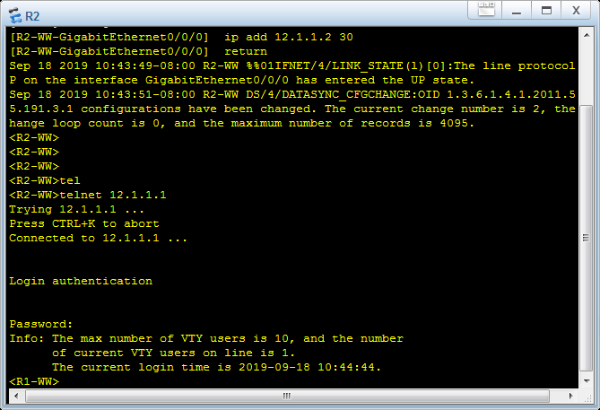

实验二

The device is running!

<Huawei>system-view

Enter system view, return user view with Ctrl+Z.

[Huawei]sysname R1-WW

[R1-WW]int g0/0/0

[R1-WW-GigabitEthernet0/0/0]ip address 12.1.1.1 30

[R1-WW-GigabitEthernet0/0/0]quit

[R1-WW]aaa

[R1-WW-aaa]local-user WW password cipher 123

Info: Add a new user.

[R1-WW-aaa]local-user WW service-type telnet

[R1-WW-aaa]local-user WW privilege level 2

[R1-WW-aaa]quit

[R1-WW]telnet server enable

Info: The Telnet server has been enabled.

[R1-WW] user-interface vty 0 4

[R1-WW-ui-vty0-4] authentication-mode aaa

[R1-WW-ui-vty0-4] quit

Sep 18 2019 10:49:54-08:00 R1-WW %%01IFNET/4/LINK_STATE(l)[0]:The line protocol I

P on the interface GigabitEthernet0/0/0 has entered the UP state.

[R1-WW]

[R1-WW]

Sep 18 2019 10:49:57-08:00 R1-WW DS/4/DATASYNC_CFGCHANGE:OID 1.3.6.1.4.1.2011.5.2

5.191.3.1 configurations have been changed. The current change number is 6, the c

hange loop count is 0, and the maximum number of records is 4095..

R2

The device is running!

<Huawei>

<Huawei>

<Huawei> system-view

Enter system view, return user view with Ctrl+Z.

[Huawei] sysname R2-WW

[R2-WW] int g0/0/0

[R2-WW-GigabitEthernet0/0/0] ip add 12.1.1.2 30

[R2-WW-GigabitEthernet0/0/0] return

Sep 18 2019 10:50:08-08:00 R2-WW %%01IFNET/4/LINK_STATE(l)[0]:The line protocol I

P on the interface GigabitEthernet0/0/0 has entered the UP state.

Sep 18 2019 10:50:08-08:00 R2-WW DS/4/DATASYNC_CFGCHANGE:OID 1.3.6.1.4.1.2011.5.2

5.191.3.1 configurations have been changed. The current change number is 2, the c

hange loop count is 0, and the maximum number of records is 4095.

<R2-WW>

<R2-WW>

<R2-WW>

<R2-WW>tel

<R2-WW>telnet 12.1.1.1

Trying 12.1.1.1 ...

Press CTRL+K to abort

Connected to 12.1.1.1 ...

Login authentication

Username:WW

Password:

Info: The max number of VTY users is 10, and the number

of current VTY users on line is 1.

The current login time is 2019-09-18 10:51:11.

<R1-WW>

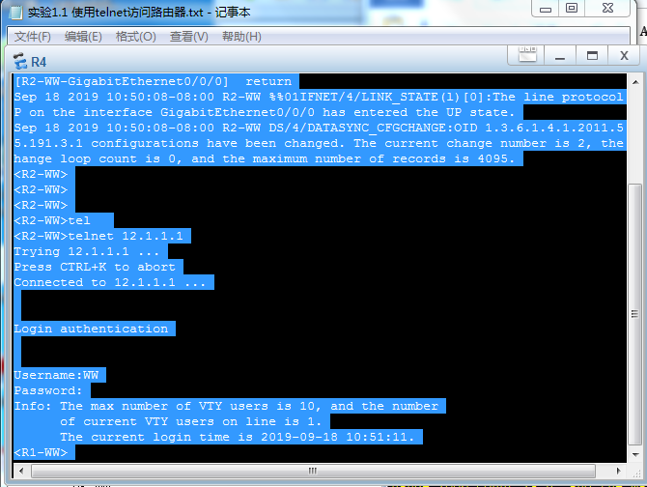

实验三

The device is running!

<Huawei>

<Huawei>

<Huawei>system-view

Enter system view, return user view with Ctrl+Z.

[Huawei]sysname R1-WW

[R1-WW]int g0/0/0

[R1-WW-GigabitEthernet0/0/0]ip address 12.1.1.1 30

[R1-WW-GigabitEthernet0/0/0]quit

[R1-WW]telnet server enable

Info: The Telnet server has been enabled.

[R1-WW] user-interface vty 0 4

[R1-WW-ui-vty0-4] authentication-mode none

[R1-WW-ui-vty0-4] quit

Sep 18 2019 10:54:28-08:00 R1-WW %%01IFNET/4/LINK_STATE(l)[0]:The line protocol I

P on the interface GigabitEthernet0/0/0 has entered the UP state.

[R1-WW]

[R1-WW]

Sep 18 2019 10:54:35-08:00 R1-WW DS/4/DATASYNC_CFGCHANGE:OID 1.3.6.1.4.1.2011.5.2

5.191.3.1 configurations have been changed. The current change number is 3, the c

hange loop count is 0, and the maximum number of records is 4095.

R2

The device is running!

<Huawei>

<Huawei>

<Huawei>system-view

Enter system view, return user view with Ctrl+Z.

[Huawei] sysname R2-WW

[R2-WW] int g0/0/0

[R2-WW-GigabitEthernet0/0/0] ip add 12.1.1.2 30

[R2-WW-GigabitEthernet0/0/0] return

<R2-WW>

Sep 18 2019 10:54:41-08:00 R2-WW %%01IFNET/4/LINK_STATE(l)[0]:The line protocol I

P on the interface GigabitEthernet0/0/0 has entered the UP state.

<R2-WW>

<R2-WW>

<R2-WW>

Sep 18 2019 10:54:45-08:00 R2-WW DS/4/DATASYNC_CFGCHANGE:OID 1.3.6.1.4.1.2011.5.2

5.191.3.1 configurations have been changed. The current change number is 2, the c

hange loop count is 0, and the maximum number of records is 4095.

<R2-WW>

<R2-WW>tel

<R2-WW>telnet 12.1.1.1

Trying 12.1.1.1 ...

Press CTRL+K to abort

Connected to 12.1.1.1 ...

Info: The max number of VTY users is 10, and the number

of current VTY users on line is 1.

The current login time is 2019-09-18 10:58:08.

<R1-WW>

<R1-WW>

<R1-WW>

